Week 2 – October 2, 2020
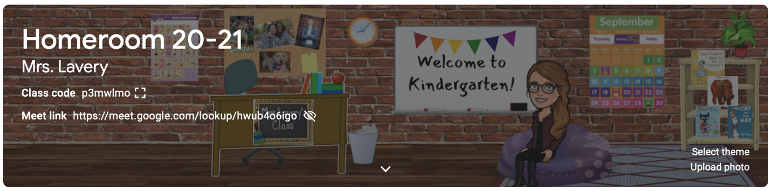

Dear Parents,

Well, we are 2 weeks in and this fragile thing we have all worked together to build is still intact! Yeah, S-G! Yeah, SAC! Yeah, YOU! Let me apologize now for the length of this week’s note, but there is a lot to go over. Hang in there!
In reading, kindergartners have been reading about making new friends, “filling buckets,” and apples! We have learned the sight words: I, a, can, the! Please consider putting these little gems on sticky notes and placing them in fun places around your house! I remember placing the words of the week on the cookie tupperwear and would only let hands in there who could read the words! It was amazing how quickly those hungry boys of mine mastered the list! I have been busy copying little practice readers and sending them home with a “Read Aloud” stamp in hopes that a grown up at home will listen to these littles point and read! Practice readers can be placed in your “book box” and taken out each night for a quick read. Feel free to give your reader as much help as they need to be successful at this point. Maybe you read first and he “echos” you. Maybe you “mumble” read along with your little. Success breeds success.
In Fundations, room 145 has been introduced to the letters: /t/, /b/, and /f/. Students should be able to look at the letter/sound cards and say the name of the letter, the keyword, and the sound it makes. Letter/sound cards can be found on the back of your child’s red take home folder. I will try to mark the letters we have learned with a glitter sticker so you can be sure which letters to practice.
In math, children explored sorting and grouping according to different attributes. We grouped according to size, shape, color, and kind! It was a fun way to begin our math instruction. Next week we move on to number recognition, formation, and counting to 5!
Please see the note in your mail today regarding this weekend’s google classroom homework! Feel free to reach out with any questions as you and your child learn to navigate room 145’s Google Classroom!
Meet the Teacher Night will be held virtually this year. Other than the date (October 14 at 6:00), I don’t have any details. However, I do know that I will have a 4 minute video to show you of how your children are navigating their days in kindergarten. I think it is so important to provide parents with a view into our classroom, especially since parents have no access to the building this year. I want to make sure you feel as much a part of this kindergarten experience as possible. I will have a short powerpoint to share and will be able to take questions. The whole thing should only run 30 minutes, but it will give us a chance to touch base as a group, so I am really looking forward to it.
Traditionally, parent-teacher conferences are held every Friday in the month of October. Of course, this year is ANYTHING but traditional! Below is my most current information as of writing this letter. When I know more, I will tell you more. I promise!

Parent-Teacher Conferences:
All conferences will be held virtually. The dates and times are the same across the district. Please see the schedule below:

Wednesday, Oct. 14th- students attend school in the AM, conferences in the PM
Wednesday, Oct. 21st- conferences in the AM, students attend school in the PM
Wednesday, Oct. 28th- students attend school in the AM, conferences in the PM
Wednesday, Nov. 4th- conferences in the AM, students attend school in the PM

Dismissal for Sac on Oct. 14th and 28th will be at 11:45am
Arrival for Sac on Oct. 21st and Nov. 4th will be at 12:45pm

Years ago, I sent my oldest daughter (now 27) off to college. I remember being so filled with hope…and fear. My hope was that I had done a good job, that I had prepared her to be independent, confident, and that I had given her the skills she would need to tackle this world without me by her side. I hoped I had told her enough times that she was smart, worthy, and capable. I hoped that she knew how very much she was loved. I was filled with hope. And then I left her there to figure out. I think this is probably how many of you felt last week, so I will tell you. You have done a good job. I am so proud of this group of kindergartners and so happy to be spending this year with them. As I told one parent this week, when you encounter a 5-year-old who is compassionate, empathetic, and appreciative, it really doesn’t say anything about the child, but it speaks VOLUMES about the parents who whispered in their ears for five years. You would be so proud of how your children are behaving out in the world.

Thank you for returning paperwork and homework. I know that when a kindergartner returns his homework, with his name on it, directions followed - it is because he had a grown up by his side cheering him on. Thank you for your support and encouragement. It takes a village and I am glad to be part of yours this year.

Kim Lavery
klavery@sgcsd.net

**Don’t forget to check out our class website (different from our google classroom!) at:

http://mrslaverysgarden.weebly.com/

