Week 3 – October 9, 2020
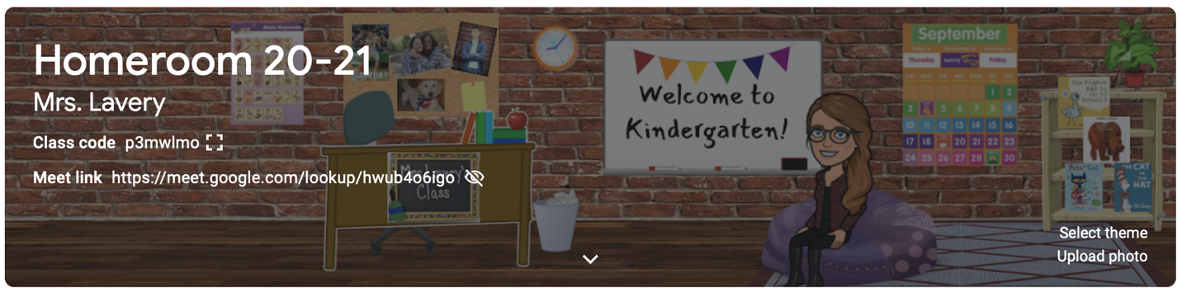

Dear Parents,
Welcome, FALL! This week, kindergarten enjoyed being leaf collectors, sorters, and designers! We did leaf paintings, rubbings, and watched videos on the WHY and HOW leaves change color!
In reading, students continue to work on the sight words: I, a, can, & the. We look for “our words” in our classroom and when reading songs and books. Students practiced reading and writing these words all week long, so I am hopeful that we are approaching mastery level when it comes to these beginning sight words. Please see attached popcorn sight word cards for you to cut apart, place in a zip bag, and put in your child’s book box to make review easy. Again, I’m a big supporter of putting these words on sticky notes around the house this weekend and challenging your young reader to read and spell them whenever he/she passes them in the house! Remember to have your child reach into his/her book box every day and read SOMETHING!
Our class focused on two main reading strategies this week. THE WORDS NEED TO MATCH THE PICTURES – so always look for illustrations for clues, and POINT TO THE WORDS WHEN READING. When young readers point to words, it encourages them to focus on the print when saying the words that very often – have been memorized. Both of these are key strategies for emergent readers.
In FUNdations, room 145 has added two new letters to our collection: /m/, and /n/. Students should be able to look at the letter/sound cards and say the name of the letter, the keyword, and the sound it makes. Letter/sound cards can be found on the back of your child’s red take home folder. You will see that I have added a glitter sticker to those letters to show that they are letters kindergartners are expected to know.
In math, children explored reading, writing and counting groups of 5. We practiced crossing out as we count (when counting items on paper), touching and moving items as we count them, and pointing. Careful counting is an important skill for littles to master, so we will continue to work on it. Number formation, especially forming the numbers 2, 3 and 5, can be the most troublesome of all letters/numbers! In your child’s take home folder (in a page protector) you will find our number formation rhymes that help us remember how to make each number.
Please see the note in your mail today regarding this weekend’s google classroom homework! Feel free to reach out with any questions as you and your child learn to navigate room 145’s Google Classroom!
Meet the Teacher Night will be held virtually this year. You will be receiving a link to join the presentation. I showed the class the video of “A Socially Distanced Kindergarten” and they are thrilled to have you watch it and see what their day looks like! Although I held many “meets” last year with my class, this is the first time I will be conducting a Meet the Teacher Night virtually. One thing I am sure of….there will most likely be technological challenges! We will get through it together! Please make sure to be on the google meet at 6:00. I have been told that I will need to shut it down at 6:30 because the next grade level will be presenting at that time.
I am working on the best way to schedule parent teacher conferences and will be sending out a sign-up genius to everyone. If you gave me more than one email, an invite will be sent to each of the email addresses. Please be sure to sign up for only one slot per child.

Parent-Teacher Conferences:
All conferences will be held virtually. The dates and times are the same across the district. Please see the schedule below:

Wednesday, Oct. 14th- students attend school in the AM, conferences in the PM
Wednesday, Oct. 21st- conferences in the AM, students attend school in the PM
Wednesday, Oct. 28th- students attend school in the AM, conferences in the PM
Wednesday, Nov. 4th- conferences in the AM, students attend school in the PM

Dismissal for Sac on Oct. 14th and 28th will be at 11:45am
Arrival for Sac on Oct. 21st and Nov. 4th will be at 12:45pm

Fall is a special time for me. As I mentioned last week, we were celebrating my oldest daughter’s 27th birthday. Her actual birthday was October 6th and I still remember looking down at her eyes in 1993 for the first time. Like you, I had no idea how many diapers I would change, tears I would dry, or sticky kisses I would receive. I didn’t know how many nights I would wait up for her, how many decisions of hers I would have to trust, or how good I would have to get at saying goodbye. I only knew, like you, that my life would never be the same. And it hasn’t. Every fall I am reminded of how life continues to change and my role as a mother changes with it. I have learned that although it is difficult to say goodbye to those stages when our littles need us so desperately, know this…the stage that replaces it is good, too!

Have a great weekend!

Kim Lavery
klavery@sgcsd.net

**Don’t forget to check out our class website (different from our google classroom!) at:

http://mrslaverysgarden.weebly.com/

This is where I will post our back to school video: “A Socially Distanced Kindergarten” and pictures throughout the school year!

