Week #4 – October 16, 2020
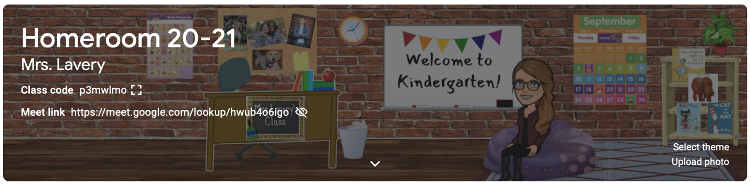

Dear Parents,

Kindergartners packed a lot of pumpkins into this week! We painted, sorted, patterned, and read all about pumpkins! This week our literature selections (The Little Old Lady Who Wasn’t Afraid of Anything, The Ugly Pumpkin, and Pumpkin, Pumpkin) focused on predicting and sequencing. We practiced the poem, The Five Little Pumpkins and learned how to illustrate so our pictures ALWAYS match the words. So far in kindergarten, we have learned the words: see, am, I, a, the, we, can,). When presented with the word on a card, students should be able read it, spell it, and read it! We practice this at school every day!
In math children finished Topic 1 which focused on counting groups to 5 and writing numbers 1-5. In this unit, children learned correct number formation, how to move objects when counting, and how to cross and count items on paper to assure accurate counting. Next week we move on to ordering and comparing numbers to 5.
In FUNdations this week, students were introduced to their first vowels! It’s very exciting because with the addition of “i” and “u,” we can start to sound out words when reading and writing! You will find a glitter smiley face next to the letters: b, t, f, m, n, u, & i on the FUNdations keyword/letter chart in your child’s take-home folder to show that these are letters we have mastered! Next week, we will not add any NEW letters, but spend some time perfecting the ones we have “collected” so far!

I was surprised this weekend by an impromptu visit from my college boy, Ben! For 48 hours my washing machine purred, my sink overflowed, and my refrigerator emptied, but my heart filled. There was football in the front yard, firepits in the back yard, and teenagers sleeping till noon. For 48 hours, I was surrounded by the familiar sounds of a full nest. And then it got quiet. This weekend, just before you tell everybody to keep it down, listen. Listen to the sounds of your full nest and create a memory that you can pull up when the days get quiet. Have a great weekend!

Kim Lavery
klavery@sgcsd.net

*Looking for a parent with pumpkin connections that might be able to secure a set of small pie pumpkins for our friends in room 145 to paint this year! Magic olk-a-dot pumpkins are my favorites! I know you will love them, too! Please let me know if you can hook our artists up!

*I have reached out to the principal for guidance on what our Halloween party will look like this year and will let you know as soon as she gets back to me.

*October 21st is a ½ day for parent teacher conferences. Students attend in the afternoon. School begins at 12:45.

*October 28th is a ½ day for parent teacher conferences. Students attend in the morning. Dismissal at 11:45.

*November 4th is a ½ day for parent teacher conferences. Students attend in the afternoon. School begins at 12:45.

