Week #5 – October 23, 2020
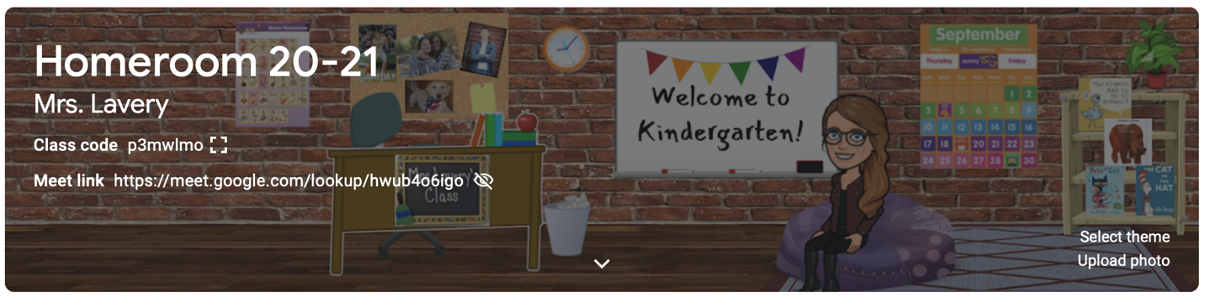

Dear Parents,

A short week for me and a bit of a hectic week for our littles, but I think we all survived. I certainly tried to squeeze in a full week of learning and fun into the last two days!
In ready, children took our Unit 1 test in Wonders! I will send these home for you, but keep in mind that during these early months, kindergartners are simply “learning” how to take a test. The results do not always accurately reflect how your child is progressing in reading at this time, but more likely how well your child can stay with the group and follow directions. Thank you to Caroline and her team for compiling a great fall scavenger hunt that went well with our reading theme this week of “Senses and Seasons!” Students wrote about what they see, smell, taste, hear, and feel in the fall.
In math children also took the Topic 1 test which focused on counting groups to 5 and writing numbers 1-5. These tests will go home next week. Please note if your child is still having difficulty counting groups and remember number formation and continue to work on those skills at home. This week we learned about making “more” and making “less” and putting numbers 1-5 in order.
In FUNdations this week, room 145 continued to work on the letters: b, t, f, m, n, u, & i. We have quite a letter “collection” going so far!

Thank you to Peeps’ dad for supplying our class with a set of pumpkins! Children LOVED the magical polk-a-dot paint! Another thank you to Lauren’s mom for donating a set of fire safety activities for our class! It truly does day a village and I am so glad to be part of yours this year!
My surprise experience with contact tracing, COVID testing, and quarantining made me truly grateful for everyday that I have been able to spend with this class. Together we have created something very fragile and it can fall apart at any second. If we HAD to shift to virtual on Monday, at least we have shared 5 weeks together developing our routines, expectations, trust, and relationships in our intimate little classroom. It would make virtual teaching and learning so much easier for all of us.

Kim Lavery
klavery@sgcsd.net

*An orange flyer with the details of our Halloween party went home earlier this week. Please let me know if you have any questions. Most important is that your child needs to wear his/her “costume” to school and be prepared to keep in on all day. Easy on and off is necessary for when nature calls! Please rehearse this at home before sending your child to school in the costume.

*October 28th is a ½ day for parent teacher conferences. Students attend in the morning. Dismissal at 11:45.

*November 4th is a ½ day for parent teacher conferences. Students attend in the afternoon. School begins at 12:45.

