Week #6 – October 30, 2020
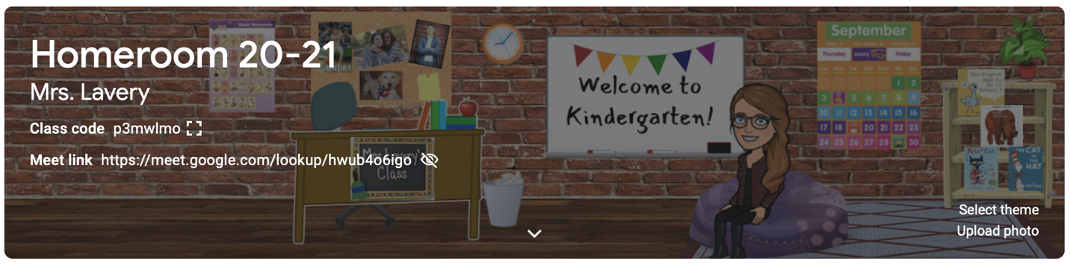

Dear Parents,

We spent a spooky week in kindergarten as we got ready for Halloween! Students read/listened to fiction and non-fiction text and gathered up facts for our first informational writing project, “All About Bats!” When we write, we practice saying the word, listening to the sound, and writing what we hear. It’s really that simple! Our reading series helped us explore tools we use to get jobs done! We continue to practice pointing/tracking our words when reading and using the clues on the page to help us with unknown words. Lots of practice readers went home this week! Please encourage your child to reach into his book box and pull out a couple old favorites to read each night! Lots of easy, predictable reading leads to confidence and fluency!
In math, children explored the vocabulary: MORE, FEWER, and SAME. This was very tricky for our youngsters! We will continue to use manipulatives and drawings to plan out these problems and increase our number sense.
Room 145 added two more letters to our collection in FUNdations this week! “O” and “c” join letters t, b, f, m, n, i, and u!
As we venture into new territory with reading, writing, and illustrating, I have been stressing the “hard” that is involved in learning new things. We can’t let our children be afraid of things that are hard. As I have told them over and over again, EVERYTHING is hard, right before it gets easy! I look for opportunities every single day to highlight things that are “hard” for me and how I LOVE the hard, because it means that I am learning new things!

Kim Lavery
klavery@sgcsd.net

*Looking for a parent with pumpkin connections that might be able to secure a set of small pie pumpkins for our friends in room 145 to paint this year! Magic olk-a-dot pumpkins are my favorites! I know you will love them, too! Please let me know if you can hook our artists up!

*I have reached out to the principal for guidance on what our Halloween party will look like this year and will let you know as soon as she gets back to me.

*October 21st is a ½ day for parent teacher conferences. Students attend in the afternoon. School begins at 12:45.

*October 28th is a ½ day for parent teacher conferences. Students attend in the morning. Dismissal at 11:45.

*November 4th is a ½ day for parent teacher conferences. Students attend in the afternoon. School begins at 12:45.

